EN 103
Dr. Palmer

Analysis Essay

Overview
This Analysis Essay will ask you to begin exploring a topic of interest by focusing on a specific idea about retail work raised in one of the following readings: Chopin’s “A Pair of Silk Stockings,” Highsmith’s The Price of Salt, or one of the short stories we read from Adjei-Brenyah’s Friday Black collection. You will be conducting a careful reading of your chosen text in order to formulate an argument about how some aspect of the text contributes to its meaning. You will need to support your argument with thorough evidence from the passage you choose.

Specifics
Before you start writing, you’ll need to spend a lot of time close reading and brainstorming:

- You will (hopefully!) not be choosing details at random—i.e., you will zero in on a theme, image, trope, metaphor, etc. that seems to confirm a larger hypothesis you have about the work. Examples might include the way Chopin’s use of royal imagery functions in “A Pair of Silk Stockings” or the role of the zombie trope in Adjei-Brenyah’s “Friday Black.” In order to determine your area of focus, you’ll want to make a series of observations about how the text makes meaning (e.g., pay attention to language and syntax, use of imagery, definitions of words you don’t know, etc).
- Once you’ve selected a focused idea for your analysis, put your hypothesis aside while you go through the steps of close reading one more time. Remember to allow your thesis to remain flexible as you re-examine the details of the text. This strategy will ultimately lead to richer, more nuanced claims about the text. Use the attached Tips for Close Reading to arrive at your argument.
- Compose a 2-page essay wherein you make an argument about how a particular aspect of the text (the details you’ve chosen) contributes to the text’s representation of consumer culture.

Note: This assignment will be challenging to complete within the 2-page page limit, so think carefully about what is necessary to include to support your argument most effectively. You should avoid an overly general introduction; instead, briefly and purposefully lead up to your thesis. The thesis claim should clearly state what insight your reading provides into the work as a whole (in particular: what does it suggest this author is saying about retail work?). The bulk of your essay should consist of a close examination of the text details, connecting quotations and examples from the text to your thesis. Students often find it helpful to first draft a version of the essay that may exceed the wordcount and then revise for focus and purpose to cut it down.

Goals
- Make an argument about the text. Explain what you've found and why it is important.
- Demonstrate how your analysis speaks to larger ideas about retail labor at work in the text.
- Thoughtfully apply close reading methods.
- Seamlessly integrate evidence from the passage into your own prose, correctly utilizing summary, paraphrase, and direct quotation when appropriate.

Formatting
- Each assignment should be roughly 2-pages long (between 500-650 words), typed, doublespaced. Use 1-inch margins and have name, class, assignment title, and date at the top left corner of the first page.
- Citations should be formatted according to MLA style: insert page numbers for any quotations in parentheses after the quote (just the page numbers; no pp. or p.).
- Include a Works Cited page for your source (i.e., “A Pair of Silk Stockings”). This should be a separate third page.
- Submit completed assignment on Blackboard by 11:59pm on the date specified in our class syllabus.
Rubric for Analysis Essay
Total points: 200
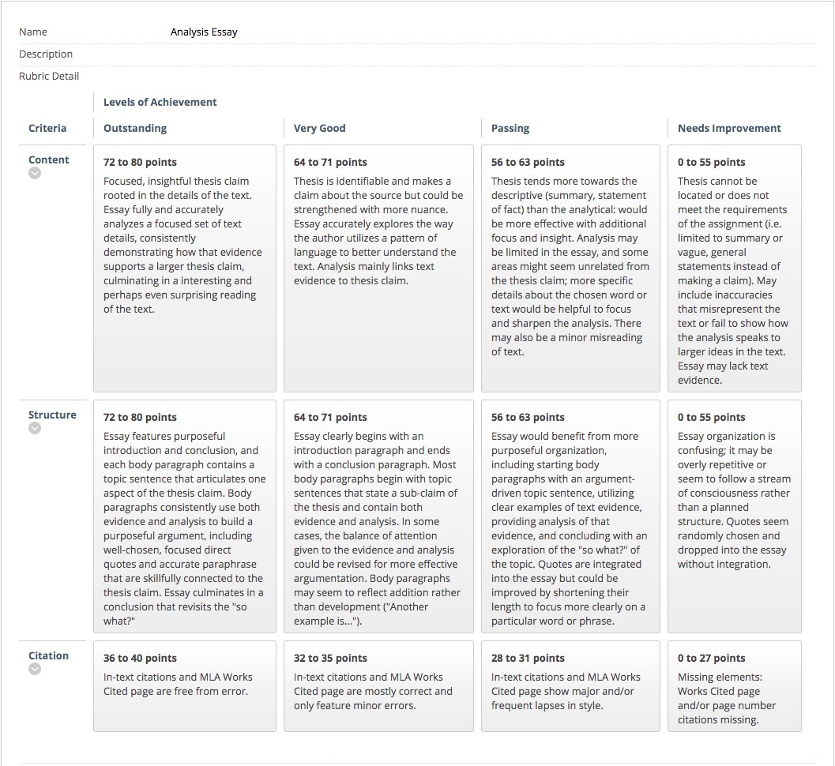

Tips for Close Reading

Summary vs. Interpretation
Interpretation differs from summary. To summarize is to retell a story in a condensed form, highlighting major events. (Note, however, that what a reader may see as a major event is often a matter of interpretation.) Summaries answer the questions: who, what, when, where, and often why, and how. They are necessary, but they can almost always be very brief, and they should always serve to illuminate your analysis and interpretation.
To interpret, is to explain how a text is meaningful: what ideas a text invites a reader to explore and how those invitations arise from the text. Note that I’ve used the word “invitations.” You need not claim that your reading is the only one — in fact you should always be working in the opposite direction. In a literary interpretation, details of plot are included only to focus a reader's attention on certain aspects of a story such as events, conversations, descriptions etc. that a critic intends to focus on in a reading.
Good Interpretative Questions
Appropriate interpretative questions include: Why does a character feel or act a certain way? How does an author create the mood of a work? What effect does that mood have on you as a reader? Why is a character telling the story that he/she is telling? What effect does the text's chronology have on the story that is being told? Why are certain comparisons being made? How does a text reflect the cultural/historical context in which it was written? How does your individual response reflect your own experiences and assumptions?
What makes a "good reading" -- casting off your assumptions
The main difference between literary criticism and chemistry, sociology, history, and every other field of study, is that for the literary critic, the questions themselves and the rituals of analysis and interpretation are more significant than the answers. That’s why I really mean it when I say that the way you make your argument is more important than what you are arguing. Most offensive arguments — racist and sexist stereotypes, for example — rely on far reaching assumptions that require one to ignore a great deal of evidence to the contrary. They are often simplistic, over-generalized, and vague. This makes them poor strategies for literary interpretation. But you can also be as politically correct as it is possible to be and still make a bad, boring argument that relies on misreading and oversight.
In general, good readings recognize contradictions. Literature reveals the limitations of logical thought. When you pose the question “Is it this? Or that?” to a text, a skillfully written story answers back, “Both.” Or it may say, “Neither. It’s something you haven’t thought of yet.”
The most successful literary critics are those who continually become aware of their own assumptions. Instead of imposing their theories on the text, they let the text teach them how to see the world in a way they had previously been unable to imagine. When all is said and done, that’s what stories can do for us.

A Checklist for Writing Short, Analytic Papers

Thesis: Does your first paragraph establish an analytic--not merely descriptive--thesis? That is, do you not only introduce and describe your subject, but also articulate a focused, probing approach to this subject? Have you staked out a position or question worth arguing for? One that is not obvious, clichéd, or too general? One that can be explored within the page limits of your essay?

Evidence: Do you support your argument with sufficient evidence? Do you supply specific details from the text rather than broad generalizations? Do you analyze your textual evidence (for example, calling your reader's attention to specific words and phrases within a longer quotation), rather than merely citing or quoting a portion of the text as if its relationship to your argument were self-evident? Are you developing an analytic point with your use of evidence, not just paraphrasing or summarizing the work about which you are writing?

Structure: Has your analytic thesis remained the center of a unified paper? Are the elements of your thesis clearly joined by an organizing principle? Do your paragraphs have sharply defined topics? Do you lead the reader through them using strong, considered transitions which develop toward a particular end?

Beginnings and Endings: Is the introduction specific and focused, rather than platitudinous (and hence boring)? Does the conclusion follow from the body of the essay, rather than merely reiterating the introduction? Is the conclusion rich in thought (a fresh concluding idea, a further expansion, an exciting synthesis, etc.) or is it purely mechanical (flat, repetitious, betraying boredom)? If your key point suddenly revealed itself at the very end of the writing process, did you go back and begin again, reshaping not only your thesis paragraph but the rest of your paper as well?

Mechanics: Have you written in the present tense? (It generally results in a stronger, cleaner style. See example below.) Have you used active verbs and avoided relying too heavily on the passive voice and other forms of "to be"? Have you tried to vary your sentence structure and sentence length in order to avoid monotony? Have you left time to revise contorted syntax or awkward diction, as well as to catch all spelling and punctuation errors--so that your reader knows you care? Have you included an MLA-style Works Cited page listing your primary text of analysis?

Quotation: Have you quoted the text extensively in your essay? Are your quotations focused (3-
7 words) on specific language use and effect? Do you explain what you see as important/illuminating about each of the quotations you include? Do you remember to place quotation marks around the words you quote? Do you remember to include the page number after each quotation?

Proper quotation format: Austen describes Emma Woodhouse as “handsome, clever, and rich”
(2).

