EN 103
Dr. Palmer

Annotated Bibliography

Overview
This assignment will assess your plan for the research project as well as the breadth and depth of the research you’ve found. This Annotated Bibliography will ask you to first describe the research problem you’re exploring, including the way in which you hope to generate a better understanding of the topic. It will then list the sources you’ll use in your research paper and provide an annotation for each source. Each annotation should provide context for the source, summarize its main claims, explain how this viewpoint relates to other sources you’re using, and show how you’re planning to use this source in your research essay.

Please note: to pass this assignment, at least one source must be a full-length scholarly article you have located in a peer-reviewed academic journal using a database from lib.ua.edu.

Specifics
Organize your Annotated Bibliography into the following parts (use these labeled sections in your paper):

Part I: Overview
This section should clearly show how your topic falls under the umbrella of retail labor and what inspiration you’ve drawn from our class videos, readings, and/or discussions to pick this topic. Be sure to give a sense of how you expect your project to enhance our understanding about some important aspect of retail labor. To conclude this section, clearly state your research problem (I am studying ____ because I want to find out ____ in order to better understand ___.) using the advice from The Craft of Research Chapter 3. [40 points total]

Part II: Annotated Bibliography
You will write a citation and annotation for each source (see details below). Remember, you need at least 1 scholarly article (at minimum; aim for more!). You should have about 5-7 total entries. This list of sources should include mainly primary and secondary and up to 1 tertiary source at the most. A note on source selection: Be sure not to sacrifice quality for quantity here. Make sure that the sources you include in this bibliography are clearly relevant to your specific research problem and that they offer reliable, authoritative perspectives on your topic.

Format Citations in MLA Style. [80 points total]
- Write a full, properly formatted citation for each source using MLA 8th Edition style. Use the Little Seagull Handbook and/or Purdue OWL to verify that each entry is correct: you will be graded on accuracy.
- Order the entries alphabetically by author’s last name, and format each citation with a hanging indent so that only authors’ last names are along the left margin. (Again, you’ll be graded on accuracy.)

Annotation Content. [80 points total]
Below each source, write a brief annotation (3-5 sentences) that gives context for the source, offers a targeted summary of its main argument (using a paraphrase and short quotations to explain precise points the author makes), and then explains specifically how you’ll use it to answer your research question in your research paper. I will look for the following in each annotation:
- Context o Clarify what genre this source is (an academic article? a chapter from a book? an article from a magazine? a documentary film? a fictional film? a post on Instagram? a Tweet? a postcard? etc.). o Describe the author briefly in a manner that encapsulates his or her qualification as an appropriate source on your topic. For example: “philosophy professor Michael Sandel,” “Florida historian Canter Brown Jr.,” or “pop culture analyst Anne Helen Petersen.”
- Brief Reading of Argument or Details o Provide an accurate, complete, and brief summary of the author’s main claim. Ex: In this essay, (author name) argues that ___(summarize main claim here)_____. Be sure to include a combination of paraphrasing and direct quotation to explain specific points the author makes. If your source is not making a scholarly argument (perhaps it’s a fiction film or an Instagram post), then instead of summarizing the main claim, give a pointed description of the text’s most pertinent details and their implications for your project. Ex: In this Instagram post, (@username) features ___(important details)___ to show that _____(key message of post)____.
- Game Plan for the Paper o For primary sources: How does this data, image, text, or video help you answer your research question? Compared to other primary sources, does it offer similar evidence of a larger trend? Present a different angle on the topic? If so, what’s unique about this source that makes it worthy of including in your paper? What details will you be focusing on? Structurally, how do you plan to incorporate it into your paper? Will you use it only briefly in your introduction to launch into a different set of sources? Will it be one of two or three main pieces of evidence you provide? o For secondary sources: How will you use this source to answer your research question? Include a description of how and to what extent this source is similar to or different from other secondary sources. To do this, consider each source’s particular claims, methods, and values. Look for some tension between sources so you can most effectively explore the complexity of your research problem. o For tertiary sources: A brief description of where in your essay you’ll use this source’s information. What will this information help set up? (In other words, how will your paper benefit from its context?)

For additional help, utilize the resources and librarians at the University of Alabama Library!

Goals
- Clearly express a focused research problem.
- Present a cohesive, focused body of research that responds to the research problem.
- Correctly utilize summary, paraphrase, and direct quotation from research as appropriate to support your ideas.
- Consistently use MLA 8th edition style to format each entry.

Formatting
- Your Annotated Bib should follow MLA 8th Edition style (including alphabetical order & hanging indents). Parts I and II can be single-spaced. Use 1-inch margins and have name, class, assignment title, and date at the top left corner of the first page.
- In-text citations should be formatted according to MLA style: insert page numbers for any quotations in parentheses after the quote (just the page numbers; no pp. or p.).
- Submit completed assignment on Blackboard by 11:59pm on the date specified in our class syllabus.

Rubric for Annotated Bibliography
Total points: 200
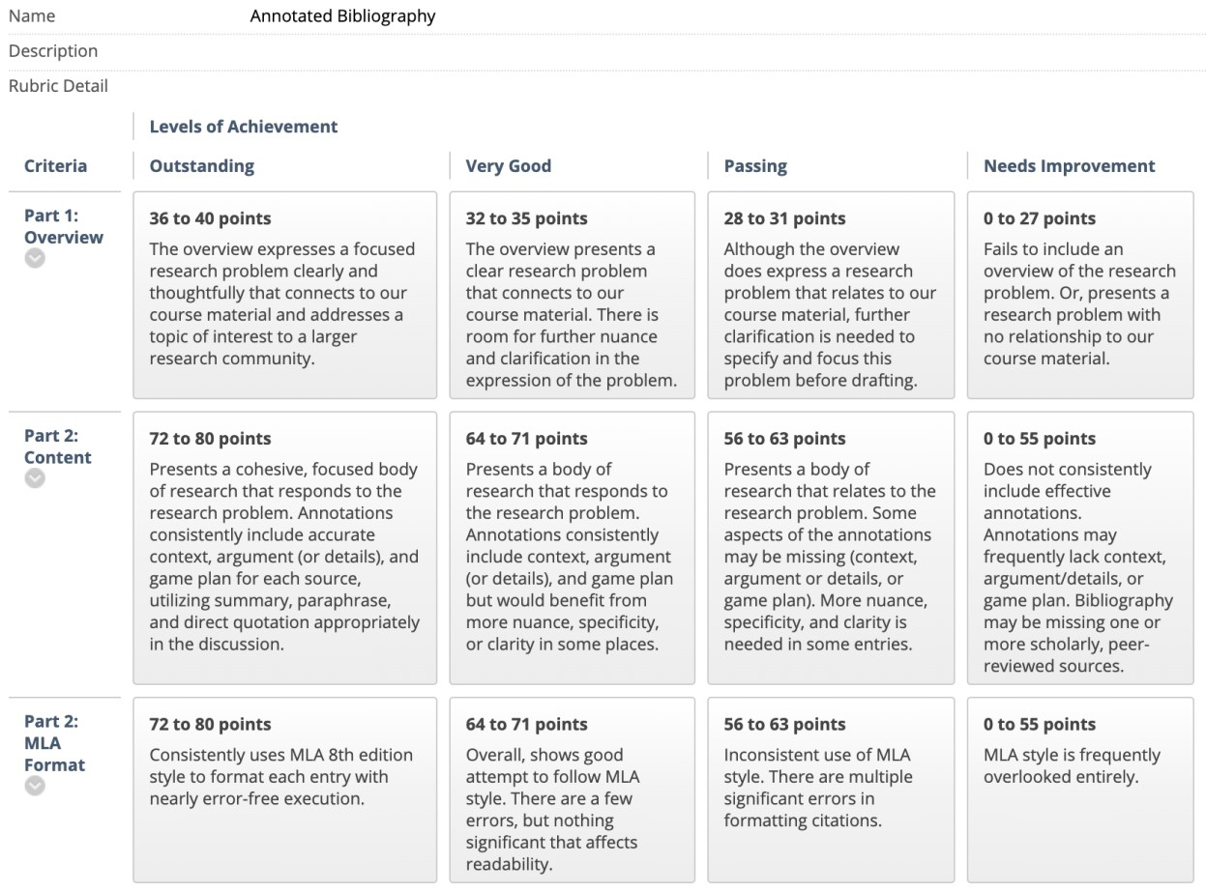

Steps Along the Way

Week 7: Research Problem & 2 Sources

For Wed, 9/30: Post a draft of your Research Problem template + 2 sources you think you might use for your Annotated Bibliography to Reading Questions: Week 7 on Bb by the start of class.

  - Fill in the research template below, following the advice from your reading in The Craft of Research Chapter 3, for the research project you think you’d like to pursue in EN 103 this semester. Remember, it should triangulate the following three areas: 1. Something to do with our course focus on retail work 2. Something you’re interested in!
3. Something other scholars are also interested in
Research Problem Template:
I am studying ___________________ because I want to find out ______________ in order to help my reader better understand ____________________.

  - Then, list two sources you think you can use to answer this research question. These can be primary and/or secondary texts for your project (please specify which). If your sources are weblinks or pdfs, feel free to insert links and/or attach the files so I can see what you're working with; otherwise, you can just list their bibliographic info here.

Week 8: Conferences

Before you draft your Annotated Bibliography, you’ll meet with me during Week 8 to discuss your plans for research. These conferences are required for the Annotated Bibliography, and any missed conferences will result in a 10% deduction to the Annotated Bibliography grade. You can sign up for a conference time slot of your choice by going to Blackboard: Course Tools: Wikis: Conference Sign Up.

On the day you signed up for, log in for your scheduled Zoom conference at your start time using the Office Hours Zoom link on Bb: Office Hours. Before your conference time, post an updated draft of your Research Problem template + 2 sources you plan to use for the Annotated Bibliography to Reading Questions: Week 8.

Week 9: Secondary Source Analysis Worksheet

For Wed, 10/14:

- Download the Secondary Source Analysis Worksheet from Bb: Assignment Sheets: Annotated Bibliography.
- Fill out the worksheet for one of the full-length scholarly articles you'll use for your research paper, and then upload the worksheet at Bb: Reading Questions: Week 9.
- Upload a pdf of the article in Bb: Reading Questions: Week 9.

Week 10: Draft of Annotated Bibliography For Wed, 10/21:

Post a draft of your Annotated Bibliography to Bb: Reading Questions: Week 10. You’ll need to have at least 3 fully completed entries in your Annotated Bibliography draft for Wednesday.

